THE SHIPPING INTENSIFICATION IMPACT ON
THE BLACK SEA ECOSYSTEM

E. N. Sibirtsova, Institute of Marine Biological research RAS, elenasibircova@yandex.ru,
Yu. N. Tokarev, Institute of Marine Biological research RAS, y.tokarev@gmail.com,
I. S. Chuprina, Institute of Marine Biological research RAS

Key words: the Black Sea, vessels exploitation, plankton, nekton, microplastic debris

I. Introduction

The water objects for a long time are considered to be first of all a “bottomless storage” of food raw material (with which development of fishing industry is connected), source of drinking and economic water supply, as well as transport routes, providing connection between far located countries and continents. Shipping is the most ancient branch of transport and for a long time it was considered to be ecologically the most safe kind of the anthropogenic load on the water ecosystems. But from the second half of twentieth century it began to be of enormous scale: scientific – technical revolution sharply changed the size of vessels, especially this of tankers. For instance if in 1970 average tankers tonnage made 42 thousand tons, already in 1980 – 96 thousand tons, while half tonnage of the World tanker fleet was made by supertankers (more than 200 thousand tons) [25]. Disturbances of the water ecosystems ecological balance for a long time remained out of vision and attention of the ecological organizations.
Only quite recently, about 40 years ago the European community began to introduce into procedures of projecting and construction of the shore and floating objects ecological norms and principles. International maritime organization (IMO) has created a document, regulating and limiting pollution of marine environment from the vessels – MARPOL [25]. Nevertheless by the present time many limitations and prohibitions remain only on paper.
Intensively developing shipping is one of the main elements of the technogenic load, which effects the Black Sea ecosystem as well. Estimation of the vessels exploitation consequences, destabilizing all marine biotops components by a number of the physical processes, is the aim of the given work.

II. Material and methods

The studies were conducted in the biophysical ecology department of “A. O. Kovalevsky Institute of marine biological investigations, RAS” (FSBUN IMBI). Numerous publications of the national and foreign researchers on the results of the experimental and natural works, as well as the data of our own observations served as a material for this work. In particular we used materials of the acoustic surveys, fulfilled by the researchers of the department of biophysical ecology, IBSS, in different seasons of 1980 – 2011 on board R/V “Academik Kovalevsky” and “Professor Vodyanitsky” in different regions of the Mediterranean basin seas.

III. Results and discussion

As a result of the material analysis a number of the aspects of vessels exploitation influence on the Black Sea ecosystem has been revealed; by the authors opinion the main of them are the following:

- Pollution of water thickness by oil and oil products, bilge waters, lubricants, fuel, garbage etc.;
- Appearance of “depression zones” for normal functioning of water ecosystems as a result of the marine routs active intensification (for example photic layer decrease due to water thickness turbidity and shipping channels overdeepening);
- Noise pollution of environment;
- Introduction of alien for this region species of hydrobionts with the vessels ballast waters;
- Marine environment pollution by plastic garbage.

It is known that oil and oil products are the most distributed pollutants in the World Ocean [15, 19]. Due to the closed form and limitation of water exchange in the Black Sea and considerable influence of the river discharge its ecosystem is especially sensitive to such pollution. Great potential danger is represented by transportation of oil and oil products by sea and activity of the oil terminals to the contrary of the river and shore discharges, giving regular (chronic) pollution [7].
At present time Black Sea is active oil transport corridor from East to West. About 20 thousand tons of the oil products every year can get into marine environment without consideration of technological leakages under damages, estimated as 0,01% of the transported oil products volume [7]. Ecological state of the Black Sea north-western part is of special concern. Being the region of fishery, spawning and fatting for many food fishes the Black Sea north-western part shelf is of great fishing importance. The studies conducted by the Novorossiysk biological station as early as in 70 - 80-th revealed changes in distribution of some species of animals and plants under oil pollution in the region of the Novorossiysk bay. For example zostera and cystozeira, earlier abundantly developing in the most shallow parts of the sea went down to 3 m depth. Mussel, which distributed in mass in the middle part of the gulf shifted to the open deep lots with less polluted waters [16].
Modern studies [12] have shown that by the level of the oil pollution in water thickness in the Black sea north-western part the most high pollution level (up to 10 MAC) was fixed in the Kerch near-strait zone in 1993 – 1998, which is conditioned by located there anchorage with goods re-loading and intensive shipping (especially increased after the Caspian Pipe-laying Consortium being put in work in2003). In the period of 1999 – 2008 the oil pollution level in this region remained to be still high (5 – 6 MAC).
Oil in different concentrations influence differently development of unicell algae. For instance in concentrations range from 5 to 50 mg·g⁻¹ rate of photosynthesis and abundance of microalgae in 1 – 7 days decrease for 50 % if compared with previous condition [19]. Considerable influence oil products cause on the Black Sea zooplankton as well. It has been stated that with oil concentration of 2 mg·l⁻¹ decapods larvae perish in4 days. Shrimp Leander adsrersus under 0,5 mg·l⁻¹ concentration perishes in 1 – 3 days. Mollusk Cerastoderma glaucum under 10 mg·l⁻¹ concentration perishes in 2 days, and with 5 mg·l⁻¹ concentration – in 13 days [16]. Fish, living in water containing more than 0,6 mg·l⁻¹ of oil products, acquires oil smell during one day. Oil contents in water in proportion 1:10000 is maximum admitted concentration for fish. Under an influence of oil hydrocarbons there take changes in the nervous system, blood, liver, number of B and C vitamins changes as well [16]. Oil origin hydrocarbons are able to be easily absorbed by suspended particles and accumulated by hydrobionts and finally they are concentrated in marine bottom sediments.
Superficially active hydrocarbons (SAH) are considerably concentrated in marine organisms and water plants. Especially dangerous are SAH, accumulated in the fish organs and tissues even with low concentration in habitat. Cancerous SAH were found in whiting, anchovy, sprat, red mullet, goby, bass, horse-mackerel [20]. Much SAH is accumulated in sea- snail liver, it depends on its habitat. Algae accumulate the lest number of SAH [10].
The main role in the oil products destruction in water belongs to microorganisms – destructors. At summer period superficial waters microorganisms can oxidize 1,2 – 2,5 oil hydrocarbons in 1 litre. But due to active transformation and degradation of the oil products their structure changes and more and more stable for transforming substances or toxic products are formed [15, 30].
Besides danger of oil and oil products pollution in the regions of the most intensive shipping there appears a zone of “ecological risk” – suppression of marine ecosystems normal functioning. Catastrophic condition of the “Zernov phyllophora field” in the Black Sea north-western part is a bright example of technogenic load (including shipping). From 2008 “Zernov phyllophora field” was declared to be the state nature reserve, but phyllophra still vanishes [22]. The such situation has been caused not only by an increase of gas – oil mining and bottom trawling of fish and mussels, but also by sharply grown load shipping in this part of the Black Sea. At present time there with depths of 20 – 22 m vessels with 70 – 80 – 100 thousand tons displacement pass; their propellers disturb bottom sediments and they are spread with current to quite great distances. As a result water transparence sharply decreases, sun radiation penetrates considerably worse and phyllophora perishes. At the end of 1970-th general phyllophora mass on the Black Sea shelf decreased from 10 to 1,4 million tons, and by the middle of 1980-th it did not exceed 0,3 million tons [14, 16].
Since opening in 1908 “Zernov phyllophora field” could be considered as an indicator of the BSNW ecosystem ecological condition. For the last decades intensive mining of phyllophora, bottom trawling of precious food fish, anthropogenic Eutrophication, connected with an influence of Danube, Dniester and Yuzhny Bug rivers discharge, as well as active usage of this region transport corridors by vessels turned the Black Sea north-western shelf into half-desert. As a result the greatest ecological catastrophe took place in the Black Sea basin – sharp decrease of the “Zernov phyllophora field”, the only in the world accumulation of unfixed phyllophora (fig.1). Opinion of the leading IMBI researchers is about 50 years will be needed to restore this biocenosis [14].
Investigations of the water column optical properties, conducted in the department of biophysical ecology of IMBI testify to a “vessel factor”, followed by catastrophic consequences for the “Zernov phyllophora field”. For instance value of intensity of the photosyntetically active radiation in the “Zernov phyllophora field” near-bottom layer with lighting of the water surface in the limits of 3600 -27000 lux changed from 0,33 to 3,21 mkE·m⁻²·c⁻¹.
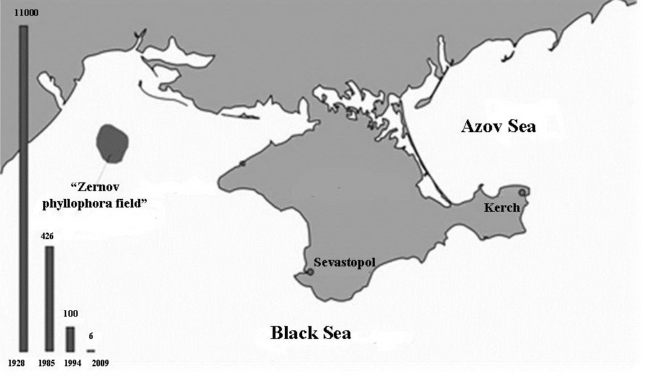

Fig. 1. Long-term changes of “Zernov phyllophora field” biomass [14].
After converting FAR units to light units it appeared that maximum light at the near-bottom layer of the phyllophora field we measured at the period from 01.11.2010 to 07.11.2010 was less than 200 lux – compensative point of phyllophora photosynthesis in the given season of the year as a result of water column transparency decrease due to the bottom sediments turbulence by the passing vessels.
Appearance of the “ecological risk” zones is also provoked by overdeepening of the river mouth shipping channels. There also takes place crucial reconstruction of the river bed: discharge of the bottom sediments from the river fairway zone with their further sedimentation in relatively calm and distanced from the shipping routes places – on the shallow waters, where the main spawning places are located; as a result there takes place silting of the spawning places [24]. It is also the reason of the salty plume penetration into estuaries for great distances with following risk of the fresh ground waters change for salty waters, which will lead to disability of population to use fresh river water (Yuzhny Bug and Dnieper rivers, region of Kasperovka; Danube along Sulina Channel) [25].
Activation of the water transport also directly damages bioresources reproduction: when vessels pass over herring spawning places more than 85 % of eggs output perish [24]. Spawning of the Black Sea – Azov Sea herring (Aloza maeotica) takes place just in the brackish water of the gulfs and river estuaries of Danube, Dniester, Bug, Dnieper, Don, i.e. just the regions of the Black sea in which intensity of shipping is the most.
Development of maritime navigation is a reason of the water areas noise pollution. Especially it is expressed at the shallow shelves of the Black Sea north-eastern and north-western regions [22]. Even not moving vessel with working on board mechanisms is intensive source of noise. Action of the main and auxiliary vessel mechanisms, water flows around the vessel hull, action of hydrodynamic forces, occurrence of cavitation phenomenon on the blades of propellers create intensive acoustic field of the vessel. Mechanisms vibration when vessel works cover wide range of frequencies (including these of infrasound). Cavitation processes taking place under propeller rolling cause in water ultrasound vibration. Tonal vibrations of the sound frequency (phenomenon of propeller singing) are also stimulated when propeller rolls. The waves, running on the hull during movement create noise, called hydrodynamic noise.
Acoustic noises influence in different way every group of marine inhabitants. The level of effect depends on frequency, level of noise pressure and duration of noise. Noises, which occur when vessels move and work in the sea are usually much higher than threshold of reaction in fish and mammals, that is why their avoiding reaction is practically inevitable in such cases. Behavior reactions of the shoal pelagic fish (changes in movement direction, spreading, alarm reaction etc.) are registered at the distance of several kilometers (sometimes more than 10 km) from the regions of active marine routes. It is known that majority of food fish – herrings, cods, salmons and others have well developed directed hearing. The range of accepted frequencies in different fish species makes from 0,1 Hz to 2000 Hz 9 more often – up to 1000 Hz). Maximum (peak) hearing sensitivity of the most food species coincides with frequencies 20 – 500 Hz, i.e. it is in the range of maximum energy of the vessel noise spectrum [11].
Pelagic as well as demersal fish, uptake vessel noise as a strong irritator. Sensitive hearing cells of many fish species can be considerably damaged due to action of highly intensive pure noise tones (about 180 dB re 1 mPa). Contrary to some birds species, in which sensitive cells of the hearing apparatus regenerate after noise trauma [6], in fish Pagrus auratus (Berycidae) loss of hearing cells after such traumas did not regenerate even under duration of the noise effect for 58 days [13]. They registered as well progress in damaging and slow regeneration or its absence after 58 days and the end of noise action. Distance of fish reaction to the vessel noise according to the data of different investigations varies considerably, from 40 to 5000 m and more, depending on fish species, time of the day, vessel type (level of noise) and environment conditions. Avoiding reaction is accompanied with horizontal and vertical replacements of fish [11].
Acoustic fields of vessels are crucial obstacle when they use methods of passive location (noise pelengation) of the fishery objects [26]. Really, in the period of the highest “sound activity), when many fish species do not form accumulations and are spread at great water areas the sound they produce, exceeding phone noise for 20 dB (i.e. about 100 times) serve as the only means for intraspecific communication [26]. It is obvious that noise pollution effects negatively pelagic and benthic biocenoses, disorienting and even dumping some fish species, making obstacle for reproducers passing to the places of spawning or coming to deltas and river beds; thus migration routes change or spawning becomes impossible.
Still more expressed negative influence echo-location produce for plankton organisms, in particular zooplankton, which is nutritive base for fish. That is why nowadays they pay special attention to studies of the echo-locating hydrodevices work influence on hydrobionts. In particular they study an influence of active sound systems on aggregations of marine bacteria, crustaceans, fish and marine mammals and possibility of diminishing different harmful effects of echo-sounders or seismic sources [22].
For example it has been shown that even short time effect of ultrasound on microbial cells causes thinning of their cell walls [1]. This and further works were conducted for studying possibility of disinfection, for example of the ballast waters with the help of ultrasound processing. As a result it has been revealed that disinfection of water by ultrasound was effective for bacteria and zooplankton as well. But to kill bacteria much more time will be needed than for zooplankton [4].
Other aspects of the acoustic fields influence on marine organisms communities functioning seem to be important as well. For example as a result of the experiment conducted it has been shown in the work [3] that noise effect (40Hz – 20Hz) on mollusks larvae Pecten novaezelandiae led to disturbance of growth and appearance of different mutations at all the stages of mutagenesis in 46 % of the larvae studied. In the work [18] it has been stated that due to influence of the noise pollution by vessels in the waters of French Polinesia islands there took place shortening of normally developing embryo of marine hare (Stylocheilus striatus) for 21 % and mortality growth in just put out larvae up to 22 %.
In the last decades there exists crucial for the Black Sea problem of the alien species invasion, taking place mostly due to uncontrolled discharge of the ballast waters. Such “biological pollution” [8] in some cases conditions even more hard consequences if compared with other anthropogenic factors. Occurring in a new environment without usual for them parasites and predators alien species often suppress or completely displace native species. This lead to simplification of the community structure and lowering its resistance to outer effects. Introduction of the alien species can facilitate worsening of water quality, distribution of new for the given basin parasites and diseases, including these dangerous for man.
Big “intruders” with quick potential of population growth and able to develop sharply are the most harmful for the Black Sea ecosystem. Such situation was characteristic for gastropod mollusk rapana (Rapana venosa), having got here from the Pacific Ocean in 1947. This mollusk eats bivalve mollusks, destroying populations of mussels and oysters in the Black Sea. It could multiply quickly, because there are no its main natural enemies in the Black Sea – marine stars, which eat out this mollusks at their mother sea – Pacific Ocean. Only plankton larvae of this mollusk and very small fry are accessible for marine predators. From the Black Sea rapana continued its migration to the Mediterranean Sea.
Planktivorous ctenophore mnemiopsis (Mnemiopsis leidyi) appeared in the Black Sea for the first time at the beginning of 1980-th. By 1988 it distributed in mass, which led to a sharp decrease in a number of the zooplankton organisms, and correspondingly of the most important food fish. Situation meliorated in 1990-th, when another atlantic ctenophore – beroe (Beroe ovate) which eats mnemiopsis appeared in the Black Sea.
It is not correct to evaluate negatively invasions of the alien species into the Black Sea ecosystem. As species migrations and further changes – it is inevitable way of ecosystem evolution with participation of man. For example we can speak about useful introduction of a new species in the case of Beroe [22]. The data of scientific investigations testify: from the beginning of 2000-th concentration of the zooplankton crustaceans (mostly Copepoda) at corresponding seasons of the year returned to the level before intrusion of mnemiopsis. All this show, that nature has found for the aliens place in the sea food net, and they became normal part of the Black Sea plankton community [22].
Unfortunately all the above mentioned ecological consequences of the shipping intensification can not be taken away in a short time. New types of engines, new constructions, new successful innovations appear 1 – 2 times in a decade, that is why industry is unable to adapt quickly to new demands for shipping. Nevertheless today they work out and implement new “pure” technologies, due to which as well as to the law initiatives, growing ecological education and pressure from the ordering side shipbuilding industry gradually decrease its negative effect on environment. The biggest container vessels “Triple E” (400m length), began to be produced in Korea in 2013 is an example of this. They are supplied with the most modern technologies, facilitating solution of two main and old problems of the marine transportation industry: air and water pollution.
Despite such optimistic facts the authors consider pollution of the World Ocean by plastic garbage to be one of the most dangerous and non-predictable consequences of the shipping. According to the international rules (MARPOL 73-78) “Discharge into the sea of all kinds of plastics, including synthetic cables and plastic bags for wastes is prohibited”. Nevertheless 80 % of plastics get to ocean from the land sources and 20 % from the ship decks [9]. 70 % of plastic which got to ocean go down to the bottom, destroying habitat and food of the deep water inhabitants.
Degradation of the plastic materials takes place under influence of warmth, ultraviolet rays, oxygen, ozone, water, radioactive irradiation and a number of chemical interactions and is accompanied by tearing of the polymer chains. This causes change of the polymer initial properties: elasticity is lost, rigidity and fragility increase, surface becomes not smooth and plastic decays to the smallest particles. At present time plastic particles are classified (depending on diameter) as mega-particles (more than 100 mm), macro-particles (more than 20 mm), meso-particles (5 – 20 mm) and micro-particles) (1 – 5 mm) [21, 27, 28].
Particles of plastic, diminished to monomers are never destructed completely, especially in the natural conditions [17]. Complexity of degradation process in different plastic products is still a subject for discussions of researchers and lasts from 100 to 1000 years. Having sizes comparable with the sizes of plankton organisms and less [2], micro-plastic is taken up by hydrobionts, thus taking part in the process of food chain, in which man represents final link. Besides quite mechanical pollution of the hydrobionts intestinal tract, their hemolymph and other systems of organs [5], leading to disturbance of the physiological processes, breaking of tissues and organs etc. microplastic, being in marine water is able to accumulate organic admixtures, including polychlorinated – biphenils, polycyclic aromatic hydrocarbonates, oil hydrocarbonates, organochroric pesticides, alkylphenols, bisphenol A in concentrations less than ng·g⁻¹. Being got to organism these quite solid compounds are able to accumulate in the fat tissues and often have cancerous, teratogenic and mutagenic effect.
By nowadays several tens of works have been published; they are devoted to the studies of quantitative and qualitative characteristics of microplastics, distributed in different biotopes. Majority of the works prove the fact of availability of the great number of microplastic in the water column, on the surface and in the bottom sediments of the different seas. The zones of recreation are especially vulnerable. The first works on studies of distribution and sources of marine garbage (including macro- and meso-plastic particles) at the Black sea beaches of the Turkish western coast [29] have shown that number of plastic particles of 2 – 10 cm size for 1 m⁻² varied from 0,085 to 5,058 pieces. Majority was made by pieces of hard plastic subjects, like leads of ethylene bottles.
Investigations of qualitative and quantitative distribution of the micro- and macroplastic in the Azov – Black Sea basin were undertaken for the first time by researchers of IMBI RAS. The number of microplastics particles at two most popular sand beaches of Sevastopol (Omega and Uchkuyevka Beaches) (fig.2) at the spring period (March – April 2016) varies from 0,670 to 7,597 and makes averagely 2,64+0,95 [23]. The data of the microplastic samples, water column (depth 15 m) and from the bottom, taken at the stations during cruise 84 R/V “Professor Vodyanirsky” are at present time under processing and analysis.

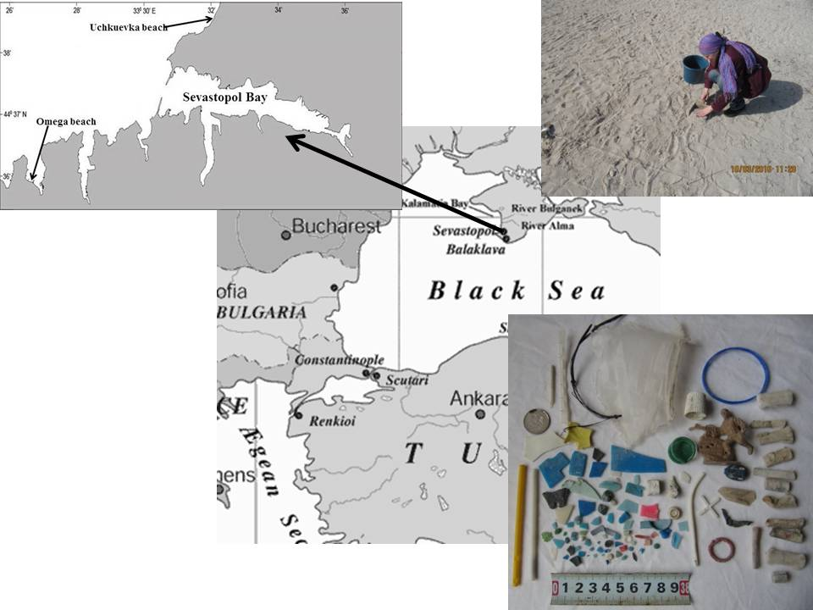

Fig. 2. Study area with sampling sites.

Taking into consideration continue unabated temps of the plastic items production and extremely low at this background indices of the enterprises on processing of the plastic garbage there exists great possibility in the nearest future of microplastic being dominating component of pelagial, benthal and surface layer of water. Accumulation of great number of plastic garbage of all size categories will lead to such crucial consequences for marine ecosystems as loss of the natural habitats for many benthic and neiston forms of organisms, disturbance of the sediments accumulation, pathologies and perishing of hundreds of marine species.
The above described consequences of the vessel exploitation in the Black Sea testify to constant influence on ecosystem of potentially dangerous technogenic load, which put in considerable and as a rule negative changes in the marine ecosystems functioning. Working out a system of monitoring of the Black Sea ecosystem condition, strict keeping to prescribed measures of safety in the vessels exploitation, usage of methods of the vessels noise supression and development of a net of new protected marine nature reserves will permit to lessen action of possible harmful consequences and make shipping one of the most ecologically safe elements of the anthropogenic factor [22].

IV. References

[1] H. Alliger, “Ultrasonic disruption,” Am.Lab. 10. – 1975, pp. 75–85.
[2] A. L. Andredy, “Plastics and the environment,” New Jersey: John Wiley and Sons, 2003, p. 762.
[3] N. Aguilar de Soto, N. Delorme, J. Atkins, “Anthropogenic noise causes body malformations and delays development in marine larvae,” Comparative psychology, vol. 24, № 2, 2007, pp. 240–249.
[4] R. A. Brizzolara, E. R. Holm, D. M. Stamper, “Disinfection of water by ultrasound: application to ballast water treatment,” NSWCCD-61-Tr, 2006, 16, 27 p.
[5] M. Cole, P. Lindeque, E. Fileman “Microplastic ingestion by zooplankton,” Environ. Sci. Technon, vol. 47, № 13, 2013, pp. 6646–6655.
[6] J. T. Corwin, D. A. Cotanche, “Regeneration of sensory hair cells after acoustic trauma,”
Science 24, vol. 240, issue 4860, 1988, pp. 1772-1774.
[7] Yu. М. Den’ga, R. I. Lisovskiy, V. Mikchailov, “Oil pollution in the Black Sea ecosystems,” Ecological problems, Odessa, 2003, pp. 123–134.
[8] I. E. Efford, C. M. Garcia, J. D. Williams, “Facing the challenges of invasive alien species in North America,” Global biodiversity, vol.7 (1), 1997, pp. 25–30.
[9] M. R. Gregory, A. L. Andrady, “Plastics in the Marine Environment,” John Wiley & Sons, Inc., Hoboken, NJ, USA, 2003, doi10.1002/0471721557.ch10.
[10] Е. P. Gubanov, М. N. Ivleva, “Oil pollution of the Black Sea and its effects on the ecosystem” Material II Inter. Conf. YugNIRO, 2006, pp. 80–95.
[11] М. Yu. Kuznetsov, V. N. Vologdin, “Hydroacoustic noise from fishing and research vessels and its influence on fish behaviour and fish stocks estimation,” Isv. ТINRO, vol. 157, 2009, pp. 334–355.
[12] А. А. Larin, L. Ph. Pavlenko, G. V. Skrypnik, “Oil components pollution of the Black Sea Russian coastal waters,” Mar. Eco. J., № 2, 2011, pp. 49–55.
[13] R. D. McCauley, J. Fewtrell, A. N. Popper, “High intensity anthropogenic sound damages fish ears,” J. Acoust. Soc. Am, vol. 113, № 1, 2003, pp. 638–642.
[14] N. А. Mil’chakova, “Macrophytobenthos. The current state of biodiversity of coastal waters of Crimea (Black Sea sector),” Sevastopol: ECOSI MHI NAS Ukraine, 2003, pp. 151-208.
[15] O. G. Mironov, I. P. Murav’yova, T. O. Mironova, “Sevastopol coasts oil pollution,” Sevastopol: ECOSI-Hydrophysics, vol.26 (1), 2012, pp. 212-216.
[16] К. Mischev, V. Popov, В. Petrova, “The Black Sea,” Leningrad: Gydrometeoizdat, 1983, p. 408.
[17] C. J. Moore, “Synthetic polymers in the marine environment: a rapidly increasing, long-term threat,” Environ. Res, № 108, 2008, pp. 131–139.
[18] S. L. Nedelec, A. N. Radford, S. D. Simpson, “Anthropogenic noise playback impairs embryonic development and increases mortality in a marine invertebrate,” Scientific Reports, 4, 5891, 2014, pp. 1-4.
[19] S. А. Patin, “Oil and ecology of coastal shelf” М.: VNIRO, 2001, p. 248.
[20] L. F. Pavlenko, G. V. Skrypnik, N. V. Deinichenko, “Oil component elements pollution ecosystem north-eastern part of the Black Sea,” Ecological problems. – Odessa: INTPONIA, 2003, pp. 253–256.
[21] P. G. Ryan, C. J. Moore, J. A. van Franeker, C. L. Moloney, “Monitoring the abundance of plastic debris in the marine environment,” Phil. Trans. R. Soc. B, № 364, 2009, pp. 1999–2012.
[22] E. N. Sibirtsova, Yu. N. Tokarev, I. S. Chuprina, “Some positive and negative consequences of shipping for the Black Sea ecosystem,” Vestnik Prikaspia, in press.
[23] E. N. Sibirtsova, “The Black Sea and microplastics: Sevastopol beaches monitoring,” unpubished.
[24] G. I. Skripka, “Ecological problems of navigation development in the Azov-Black Sea basin and their solutions,” RF Transport, № 2 (27), pp. 60–61.
[25] V. Sokolov, “Ecology and shipping in the coastal zone,” Ukrainian ports, № 08 (110), 2011, pp. 67-71.
[26] Yu. N. Tokarev, “Basin of hydrobionts biophysical ecology,” ECOSI-Hydrophysics, Sevastopol, 2006, p. 342.
[27] R. G. Thompson, C. Moore, A. Andredy, “Lost at sea: where is all the plastic?,” Science, № 304, 2004, p. 838.
[28] R. G. Thompson, C. J. Moore, S. Frederick vom Saal, S. H. Swan, “Plastics, the environment and human health: current consensus and future trends,” Phil. Trans. R. Soc. B., № 364, 2009, pp.2153-2166.
[29] E. N. Topçu, A. M. Tonay, A. Dede, A. A. Ӧztürk, B. Ӧztürk, “Origin and abundance of marine litter along sandy beaches of the Turkish Western Black Sea Coast,” Marine environmental research, vol. 85, 2013, pp. 21-28.
[30] D. S. Vorob’ov, “Impact of oil and oil products on macrozoobenthos,” Tomsk polytechnic university news, vol. 309, №3, 2006, pp. 42–45.

